Useful Definitions:
AC: Alternating Current (AC) is electric current that alternates between a positive maximum value and a negative maximum value at a characteristic frequency, usually 50 or 60 cycles per second (Hertz).
Ampere (Amps): The ampere is a unit of electric current flow. One ampere of current will flow when a potential of one volt is applied across a resistance of one ohm.
Current: Current is the flow of electric charge. Its unit of measure is the ampere.
Direct Current (DC): Direct current is current with no reversals in polarity.
Frequency: Frequency is the number of complete cycles per unit of time of any periodically varying quantity, such as alternating voltage or current. It is usually expressed as (Hz) Hertz or CPS (cycles per second).
Ohm: The ohm is a unit of electrical resistance. One volt will cause a current of one ampere to flow through a resistance of one ohm.
Power: Power refers to the rate of performing work or of expending energy. Typically, mechanical power is expressed in terms of horsepower and electrical power in terms of kilowatts. One kW equals 1.34 hp.
Volt: The volt is a unit of electrical potential. A potential of one volt will cause a current of one ampere to flow through a resistance of one ohm.
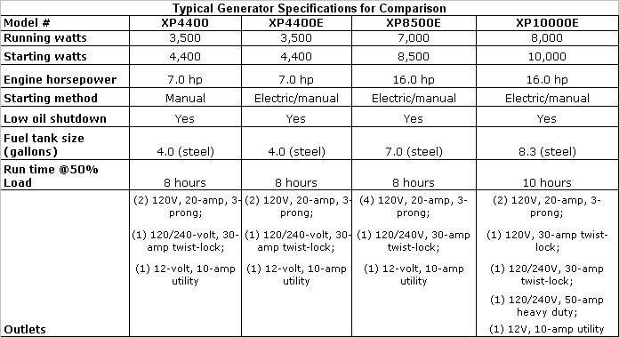
Watt: The watt is a unit of electric power. In direct current (DC) circuits, wattage equals voltage times amperage. In alternating current (AC) circuits, wattage equals effective (RMS) voltage times effective (RMS) amperage times power factor times a constant dependent on the number of phases. 1,000 watts equal one kW.

Generators vs. Inverters vs. Inverter Generators
- Conventional generators have been around for quite a while, and the basic concept behind them has remained essentially unchanged. They consist of an energy source, usually a fossil fuel such as diesel, propane or gasoline, which powers a motor attached to an alternator that produces electricity. The motor must run at a constant speed (usually 3600 rpm) to produce the standard current that most household uses require (in the U.S., typically 120 Volts AC @ 60 Hertz). If the engine’s rpm fluctuates, so will the frequency (Hertz) of electrical output.
- A traditional inverter draws power from a fixed DC source (typically a comparatively fixed source like a car battery or a solar panel), and uses electronic circuitry to “invert” the DC power into the AC power. The converted AC can be at any required voltage and frequency with the use of appropriate equipment, but for consumer-level applications in the U.S., the most common combination is probably taking the 12V DC power from car, boat or RV batteries and making it into the 120V AC power required for most everyday uses.

- Inverter generators are a relatively recent development, made possible by advanced electronic circuitry and high-tech magnets. These are generally 3-phase generators that output AC current like most traditional generators, but that current is then converted to DC, and then “inverted” back to clean AC power that maintains a single phase, pure sine wave at the required voltage and frequency.

