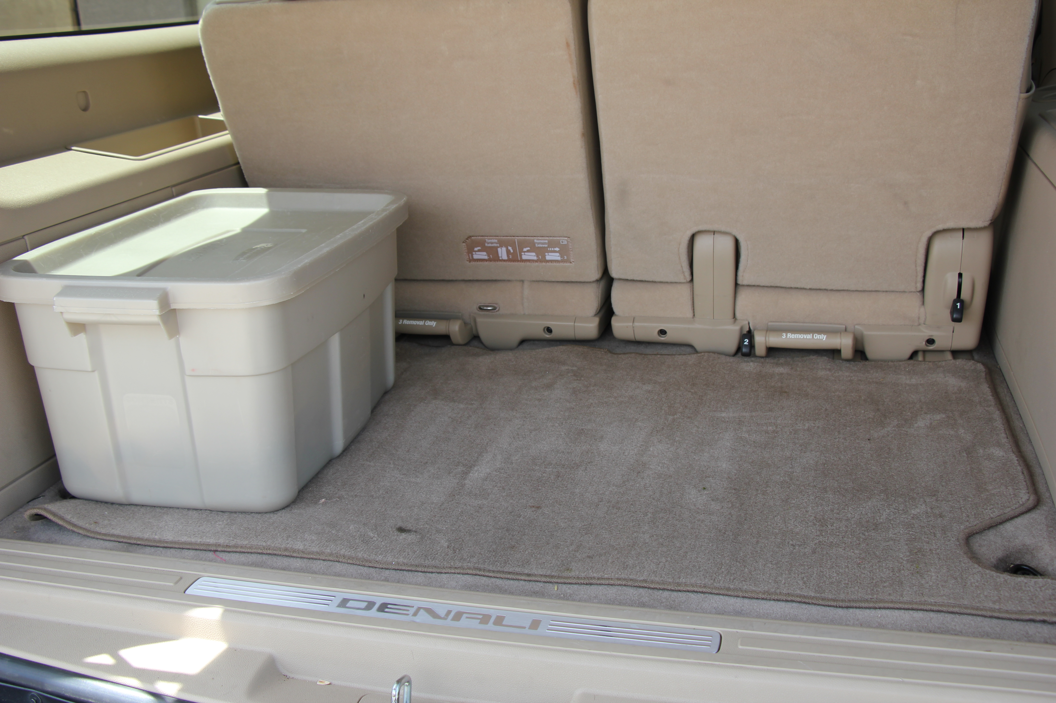
We talk a lot about food storage and 72 hour kits etc., but let’s not forget about prepping our cars. With vacation travel usually in the summer months, we should have our cars prepared for anything that can happen. Keep a plastic bin in the back of your car. Below is a suggested list of items you can put in it. Change it up for winter season and winter travel. Change the bottled water out every 6 months. Decide with your family what will benefit you based on your needs.

● Jumper cables ● Flares
● Tow strap ● Reflectors
● Blanket ● Ice scraper
● Bottled water ● Emergency information
● Snacks ● Small shovel
● Flashlight ● Fire extinguisher
● Shoes ● Matches
● First Aid kit ● Pen and paper
● Toilet paper/paper towels/wipes ● Battery powered radio
● Garbage bags ● Emergency money
●Tools ● Map
● Gloves ● Baby necessities
● Tire repair kit ● Extra quart of oil
● Whistle ● Knife

